LOGO / ARTWORK INFORMATION

WHAT IS CAMERA READY ARTWORK?

Business cards, letterhead, photocopies, hand drawings, etc. are not considered camera ready art. Any logo/artwork taken from a web site will be low resolution (72dpi) and is not camera ready art.

ACCEPTABLE SOFTWARE:

Artwork should be created in:
Adobe Illustrator: Version CS3 or lower
Corel Draw: Version X4 or lower
Export as an EPS File. Such files are generally acceptable as long as the file has been exported as an EPS file and not merely renamed as such.
Convert text to curves

WHY SHOULD I CONVERT MY FONTS TO OUTLINES?

Every computer has font files installed on it. However, not everyone has the same fonts installed on their computers. If we do not have the exact same font that the text was created in, the text will “default” to a less attractive font. Converting fonts to outlines (lines and curves) ensures that the text is exactly how you want it to look. It is no longer necessary for anyone else to have the associate font installed on their computer.

FILES WE DO NOT ACCEPT:

Any work publishing document, Microsoft PhotoDraw, Microsoft PowerPoint, Microsoft Excel, Microsoft Publisher, FreeHand, PageMaker, Adobe Image Ready, Photoshop “BMP”, “GIF or “JPG”.

2017 SPONSORSHIP FORM
13th ANNUAL MK5K & ONE-MILE FUN RUN/WALK
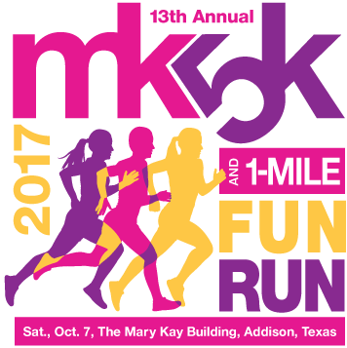

_______________________
COMPANY
_______________________
CONTACT NAME
_______________________
ADDRESS
_______________________
CITY, STATE, ZIP
_______ ________________
PHONE EMAIL

THE MARY KAY FOUNDATION℠
RACE SITE:
The Mary Kay Building
16251 Dallas Parkway
Addison, Texas 75001

Payment options:
- Please send me an invoice for $_____________
- Check enclosed made payable to “The Mary Kay Foundation”
- Donation made on www.marykayfoundation.org

Would you like a booth at the event?
- Yes
- No

- Please fax completed form to Jennifer Cook by September 8, 2017, at (972) 687-1698.
- E-mail logo to jennifer.gersic@mkcorp.com, by September 19, 2017. See back of this page for logo instructions.
- The Mary Kay Foundation℠ is a 501(c) (3) charitable organization and all contributions are tax deductible as allowed by law. Funds are due to The Mary Kay Foundation℠ by December 1, 2017.

Sponsorship Levels:

- Diamond Sponsor - $10,000 & up
- Name and logo on t-shirt
- Recognition and link on our website
- Recognition at the MK5K including stage banner, race course signage and on stage opportunity
- Billboard recognition
- Unlimited complimentary registrations
- A sponsor booth if desired

- Emerald Sponsor - $5,000 to $9,999
- Name and logo on t-shirt
- Recognition and link on our website
- Recognition at the MK5K including sponsor banner and race course signage
- Billboard recognition
- 20 complimentary registrations
- A sponsor booth if desired

- Ruby Sponsor - $2,500 to $4,999
- Name and Logo on t-shirt
- Recognition and link on our website
- Recognition at the MK5K including sponsor banner and race course signage
- Billboard recognition
- 15 complimentary registrations
- A sponsor booth if desired

- Sapphire Sponsor - $1,000 to $2,499
- Name and logo on t-shirt
- Recognition and link on our website
- Recognition at the MK5K including sponsor banner
- 10 complimentary registrations
- A sponsor booth if desired

- Pearl Sponsor - $500 to $999
- Name and logo on t-shirt
- Recognition and link on our website
- Recognition at the MK5K including sponsor banner
- 5 complimentary registrations
- A sponsor booth if desired

- In-Kind donation

_____________________________________

