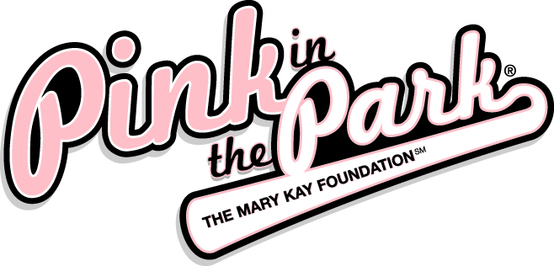

with the Frisco RoughRiders
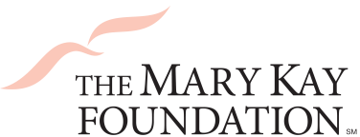
Saturday April 28 @ 7 p.m.

Benefiting:
The mission of The Mary Kay Foundation℠ is twofold:
- Eliminating cancers affecting women
- Ending the epidemic of violence against women
For more info visit http://www.marykayfoundation.org
Tickets are only $20!
What’s Included:
- A ticket to the April 28th game
- All-You-Can-Eat hot dogs, brats & nachos
- A limited-edition PINK RoughRiders cap
- Plus $5 from each ticket sold goes to
The Mary Kay FoundationSM
*Tickets without food available for $15
Recognition deadline & guaranteed seating is April 12th
Tickets will be sold on a first come, first served basis.
Detach the bottom of this form and return to the Frisco RoughRiders by April 12th
Questions? Please contact your Mary Kay Independent Beauty Consultant or call the RoughRiders at 972-334-1974.
- - - - - - - - - - - - - - - - - - - - - - - - - - - - - - - - - - - - - - - - - - - - - - - - - - - - - - - - - - - - - - - - - -
Name: ____________________________ No. of tickets at $20: _______ Total: _______
Address: _________________________ No. of tickets at $15: _______ Total: _______
City: ______________________________ Check #: ________________________________
State: ____________________________ CC#: __________________ Expiration: ______
Zip: ______________________________ Mail Payment to:
Email: ____________________________ Billy Widner 7300 RoughRiders Trail Frisco, TX 75034

Order Tickets Online (Promo Code: Pink)! www.ridersbaseball.com/MaryKay

