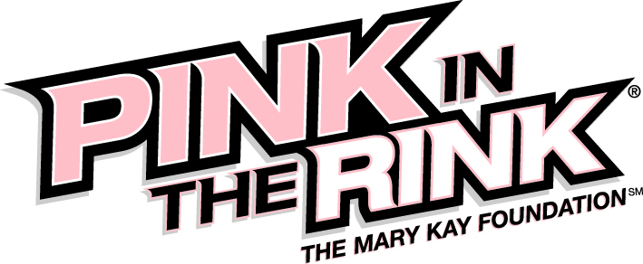

with the Dallas Stars
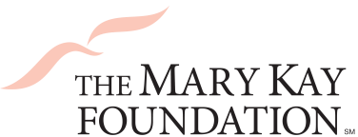
Sunday, January 31 @ 5 p.m.

Benefiting:
The mission of The Mary Kay Foundation℠ is twofold:
- Eliminating cancers affecting women
- Ending the epidemic of violence against women
For more info visit http://www.marykayfoundation.org
Packages:
Pink Ribbon Package: $30
- Terrace Seating
- Pink in the Rink® T-Shirt
Pink Power Package: $35
- Priority Terrace Seating
- Pink in the Rink® T-Shirt
*$10 from each ticket sold will go to
The Mary Kay Foundation℠
Limited Availability!
Guaranteed seating until January 17th
Tickets will be sold on a first come, first served basis.
Detach the bottom of this form and return to the Dallas Stars by January 17th or
Order tickets online at http://stars.nhl.com/marykayfoundation (Promo Code: Pink)
Questions? Please contact your Mary Kay Independent Beauty Consultant
or call the Dallas Stars at 214-387-5582.
- - - - - - - - - - - - - - - - - - - - - - - - - - - - - - - - - - - - - - - - - - - - - - - - - - - - - - - - - - - - - - - - - -
Name: ____________________________ No. of tickets at $30: _______ Total: _______
Address: _________________________ No. of tickets at $35: _______ Total: _______
City: ______________________________ Check #: ________________________________
State: ____________________________ CC#: __________________ Expiration: ______
Zip: ______________________________ Mail Payment to:
Email: ____________________________ Kyle Norris 2601 Avenue of the Stars, Frisco, TX 75034

